Online Learning Enrollment Analytics Platform End-to-End Data Engineering Project using Databricks
Project Domain: Online Education / E-Learning Analytics
Platform: Databricks
Architecture: Medallion Architecture (Bronze, Silver, Gold)
Query Language: SQL
Data Format: CSV and Delta Tables
Dashboard: Databricks AI/BI Dashboard
1. Introduction
The Online Learning Enrollment Analytics Platform is an end-to-end Data Engineering project developed using Databricks.
The purpose of this project is to transform raw online learning enrollment data into reliable, structured, and business-ready information.
Online learning platforms generate data from student registrations, course enrollments, payments, learning progress, course categories, and enrollment channels. Analyzing this information helps businesses understand learner behavior, course popularity, revenue generation, and course completion performance.
This project implements a repeatable data pipeline using the Medallion Architecture, consisting of Bronze, Silver, and Gold layers. The final processed data is used to generate business summary tables and interactive dashboards.
2. Business Problem
The online learning platform does not have an automated process to transform raw enrollment data into reliable business insights.
The raw enrollment file may contain:
- Duplicate enrollment records.
- Missing or invalid values.
- Inconsistent learner email formats.
- Incorrect or incomplete enrollment information.
- Data quality issues affecting business metrics.
The project addresses these challenges by developing a structured data pipeline that preserves the original data, cleans and validates records, separates rejected enrollments, and generates business-level summary tables.
3. Project Objectives
- Load the raw enrollment CSV file into Databricks using a Unity Catalog Volume.
- Store the original data in a Bronze table.
- Clean and validate enrollment records in the Silver layer.
- Derive learner status based on course progress.
- Store invalid or rejected enrollment records separately.
- Identify duplicate enrollment IDs and inconsistent learner emails.
- Create Gold summary tables for business analysis.
- Develop an interactive dashboard to visualize important business metrics.
- Build a repeatable and automated data pipeline.

4. Technologies Used
Technology | Purpose
Databricks | Data Engineering and analytics platform
Unity Catalog | Data governance and organization
Catalog | Organizing project data
Schema | Grouping related database objects
Volume | Storing and accessing source files
Delta Lake | Reliable table storage
SQL | Data transformation and analytics
Medallion Architecture | Organizing data processing layers
Databricks AI/BI | Dashboard development

5. Project Architecture
This project follows the Medallion Architecture.
Architecture Diagram
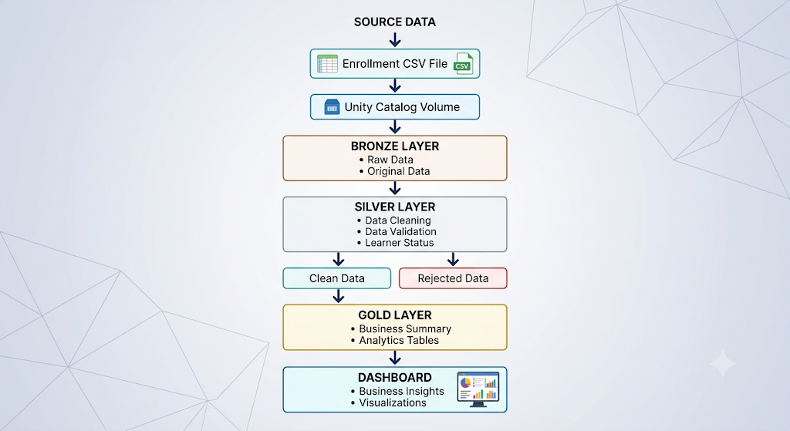

6. Databricks Environment Setup
The initial step involved setting up the Databricks environment for the project.
Unity Catalog was used to organize and manage the project data.
The following components were configured:
- Catalog: Project-level data organization.
- Schema: Logical grouping of related tables.
- Volume: Storage location for the source enrollment CSV file.
The source file was accessed from the Unity Catalog Volume and used for the ingestion process.
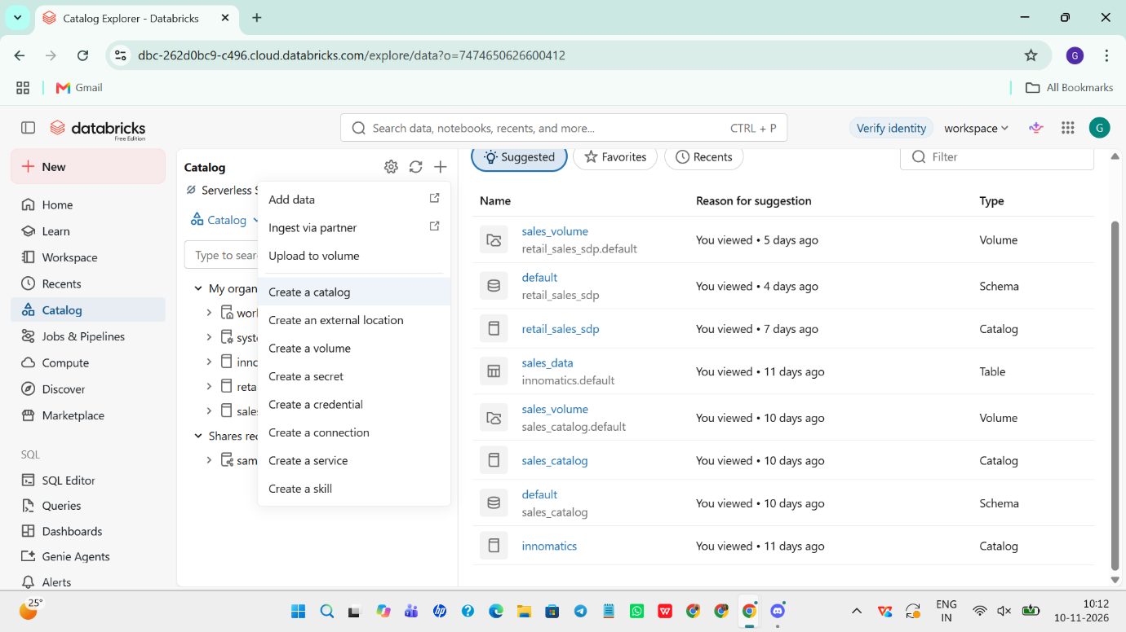

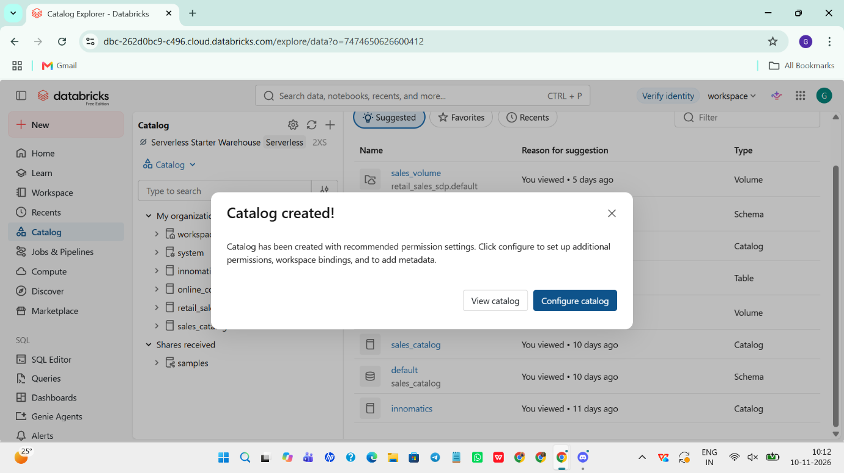
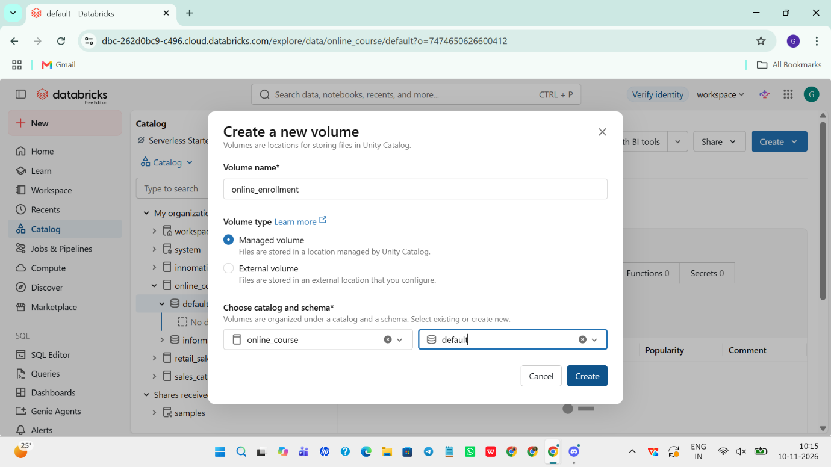

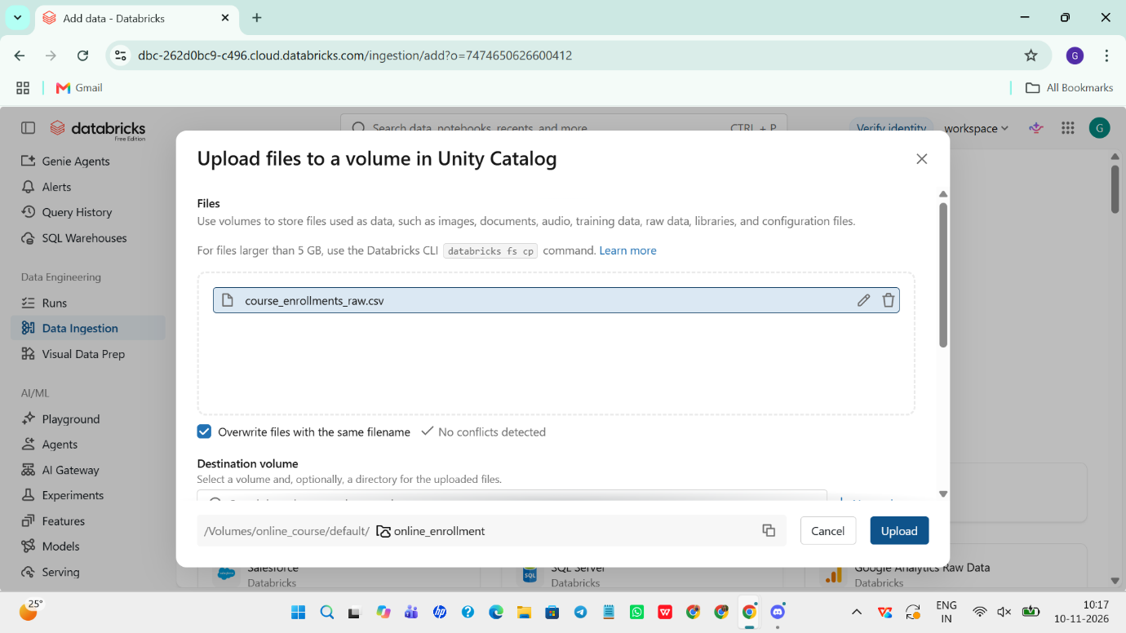
7. Bronze Layer – Raw Data Ingestion
Objective
The Bronze layer is the first stage of the Medallion Architecture. Its purpose is to ingest and preserve the original source data without applying business-level transformations.
Implementation
- Accessed the enrollment CSV file from the Unity Catalog Volume.
- Read the CSV file into Databricks.
- Loaded the raw enrollment records into a Bronze Delta table.
- Preserved the original source information for downstream processing.
Importance
- Maintains the original source data.
- Provides traceability.
- Supports data validation and auditing.
- Allows downstream transformations to be repeated.
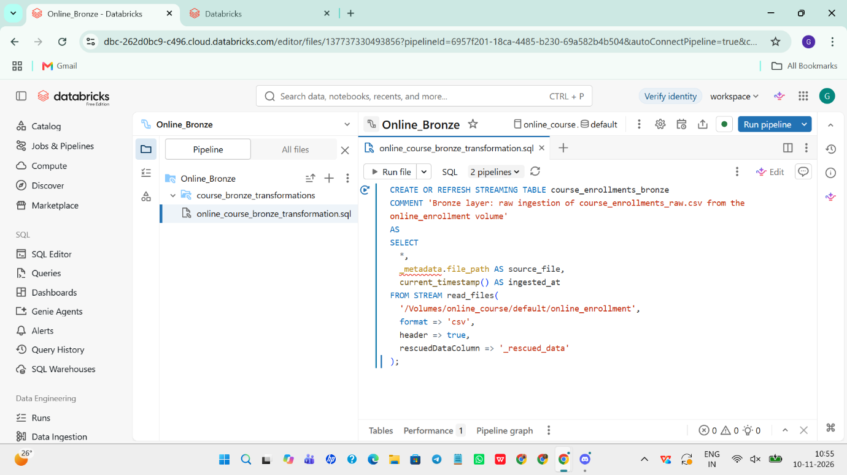

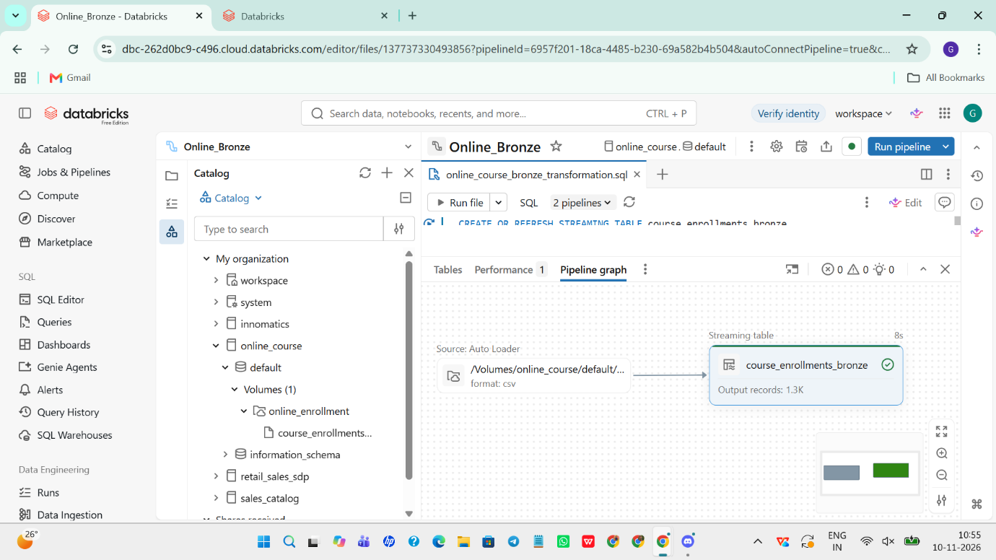
8. Silver Layer – Data Cleaning and Transformation
Objective
The Silver layer transforms raw data into clean, consistent, and validated records.
Implementation
The following operations were performed:
- Identified and handled duplicate enrollment IDs.
- Standardized learner email addresses.
- Checked missing and invalid values.
- Validated enrollment records.
- Created a learner status column based on learning progress.
- Calculated the amount paid after discounts.
- Separated invalid enrollment records into a rejected table.
Business Logic
Price Paid
price_paid = list_price - discount_amount
Learner Status
Progress | Learner Status
100 | Completed
1–99 | In Progress
0 | Not Started
Data Quality Rules
- enrollment_id must be unique.
- learner_email is not unique because one learner can enroll in multiple courses.
- Duplicate enrollment IDs are treated as duplicate records.
- Learner emails are standardized before calculating unique learners.
Output
- Cleaned Silver enrollment table.
- Separate rejected enrollment table.
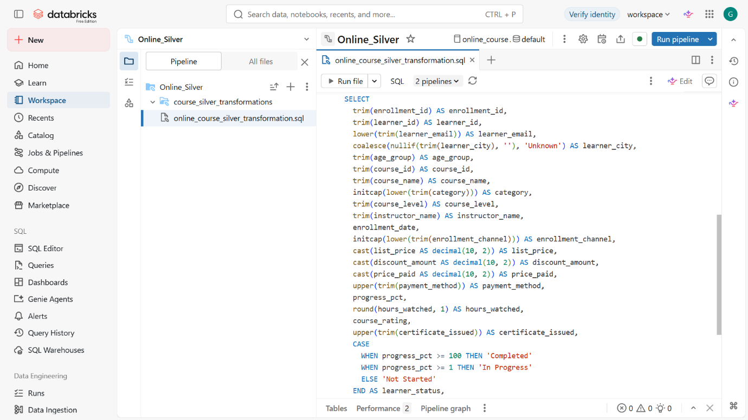

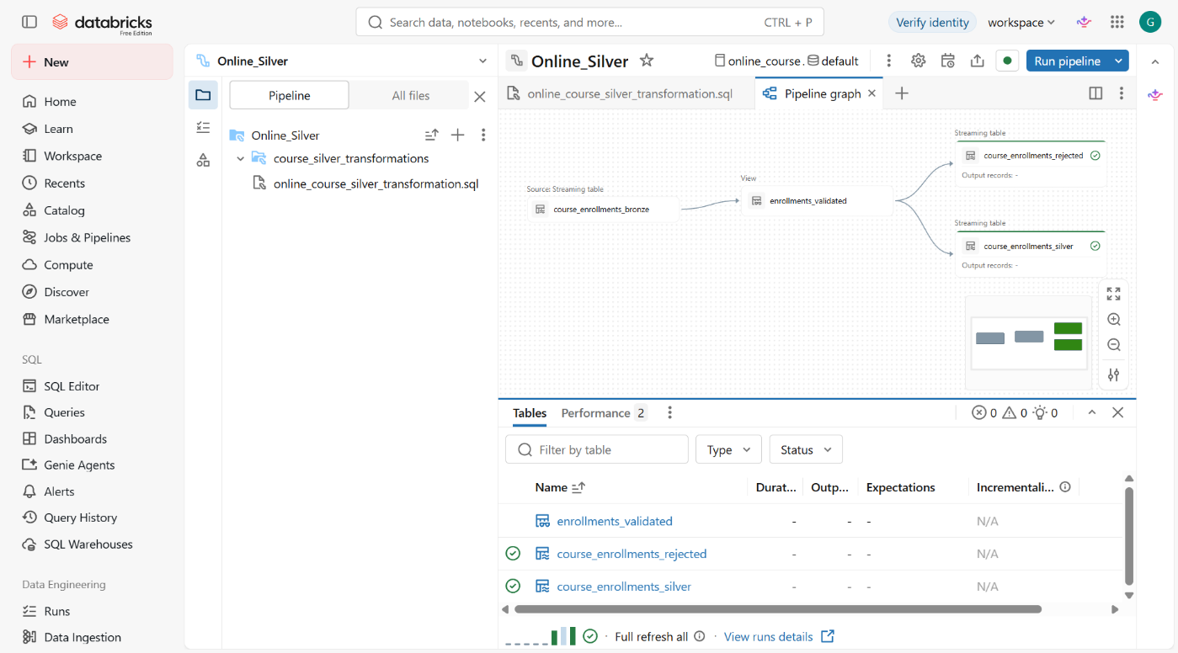

9. Gold Layer – Business-Level Aggregation
Objective
The Gold layer converts cleaned Silver data into business-ready summary tables.
These tables support reporting, business analysis, and dashboard development.
Gold Summary Tables
The Gold transformation pipeline successfully generated eight outputs.
Table Name | Business Purpose
category_performance | Analyze enrollment and performance by category
channel_performance | Analyze enrollment channel performance
course_performance | Evaluate individual course performance
data_quality_summary | Summarize data quality issues
enrollment_completion_metrics | Analyze enrollment completion metrics
enrollment_monthly_trends | Identify monthly enrollment trends
reconciliation_check | Validate data reconciliation
unique_learners | Analyze distinct learners
Key Business Metrics
Completion Rate
Completion Rate (%) =(Completed Enrollments / Total Valid Enrollments) × 100
Unique Learners
COUNT(DISTINCT learner_email)
This calculation uses standardized learner email addresses.
Revenue
Total Revenue = SUM(price_paid)
Importance
- Reduces the need for repeated calculations.
- Provides business-ready datasets.
- Supports consistent reporting.
- Improves dashboard development.
- Makes business performance easier to understand.
Execution Result
The Gold transformation pipeline was executed successfully. All eight displayed output tables showed successful execution with no errors or warnings.
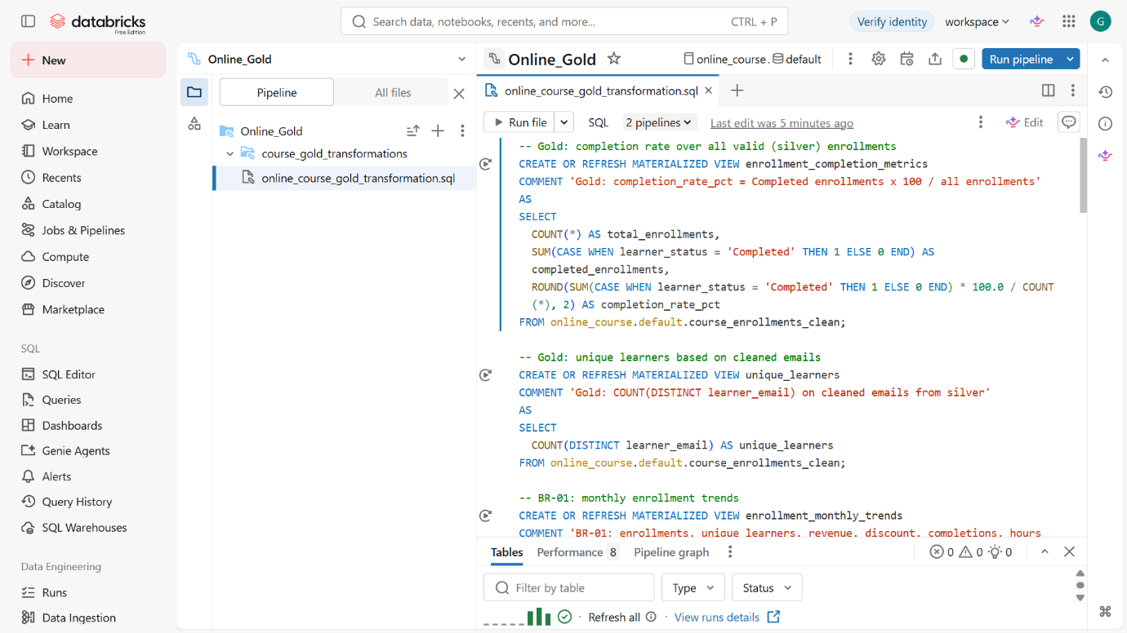

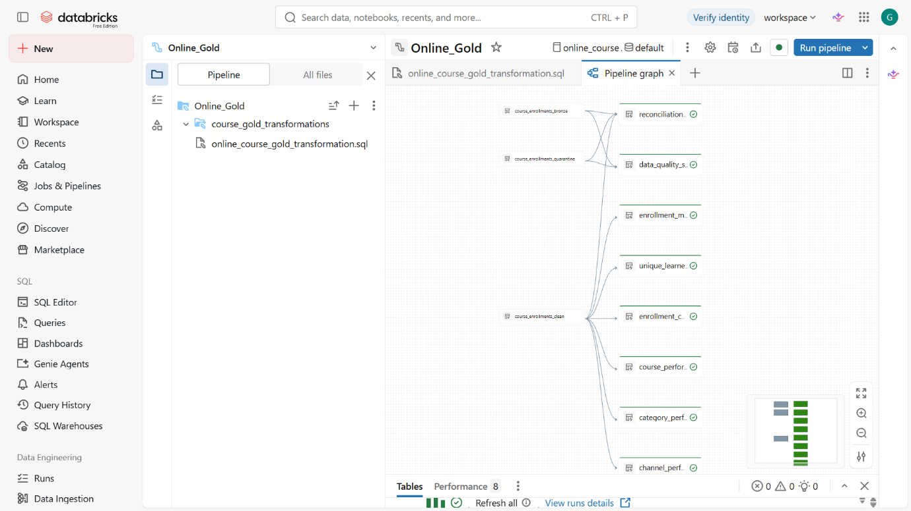

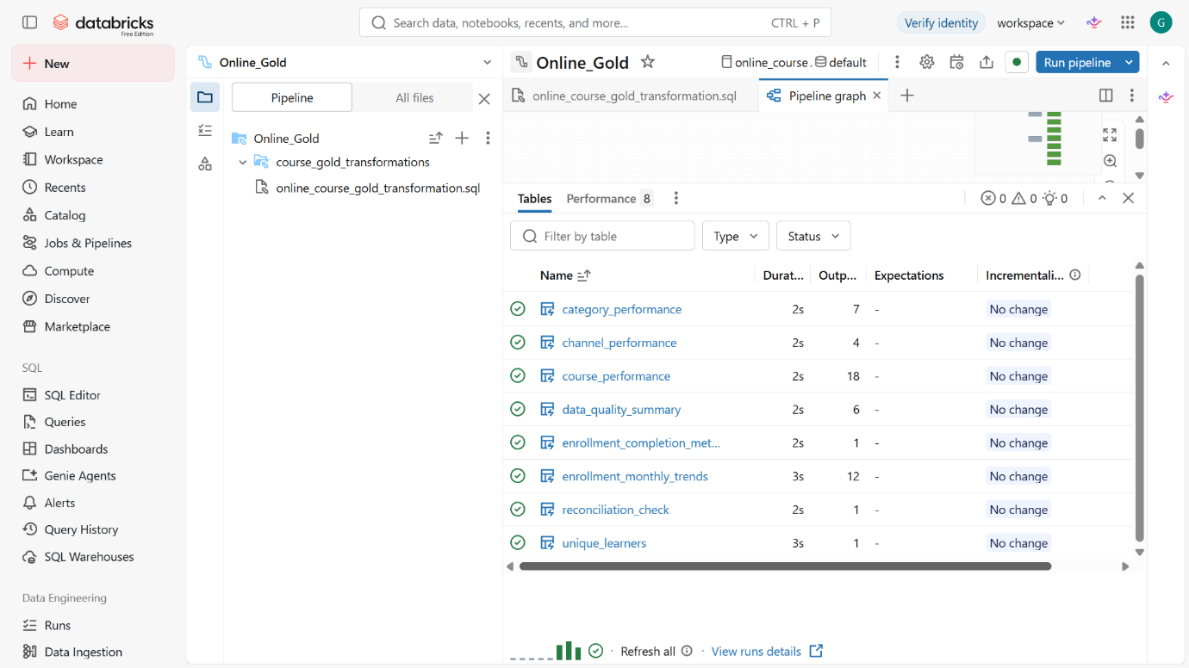

Objective
The final reporting layer presents business insights through an interactive dashboard.
The dashboard is planned with three pages.
Page 1: Enrollment Overview
Purpose: Understand the overall enrollment performance of the platform.
Planned visualizations:
- Total enrollments.
- Unique learners.
- Completed enrollments.
- Completion rate.
- Total revenue.
- Monthly enrollment trends.
- Learner status distribution.
Page 2: Course and Category Performance
Purpose: Identify popular courses and high-performing categories.
Planned visualizations:
- Top 10 courses by enrollment.
- Category-wise enrollment.
- Course-wise revenue.
- Course completion rates.
- Average course ratings.
Page 3: Channel and Data Quality Analysis
Purpose: Understand enrollment channels and evaluate data reliability.
Planned visualizations:
- Enrollment by channel.
- Channel-wise revenue.
- Channel-wise completion rate.
- Rejected enrollments.
- Duplicate enrollment IDs.
- Email normalization impact.
- Data quality summary.
- Reconciliation results.
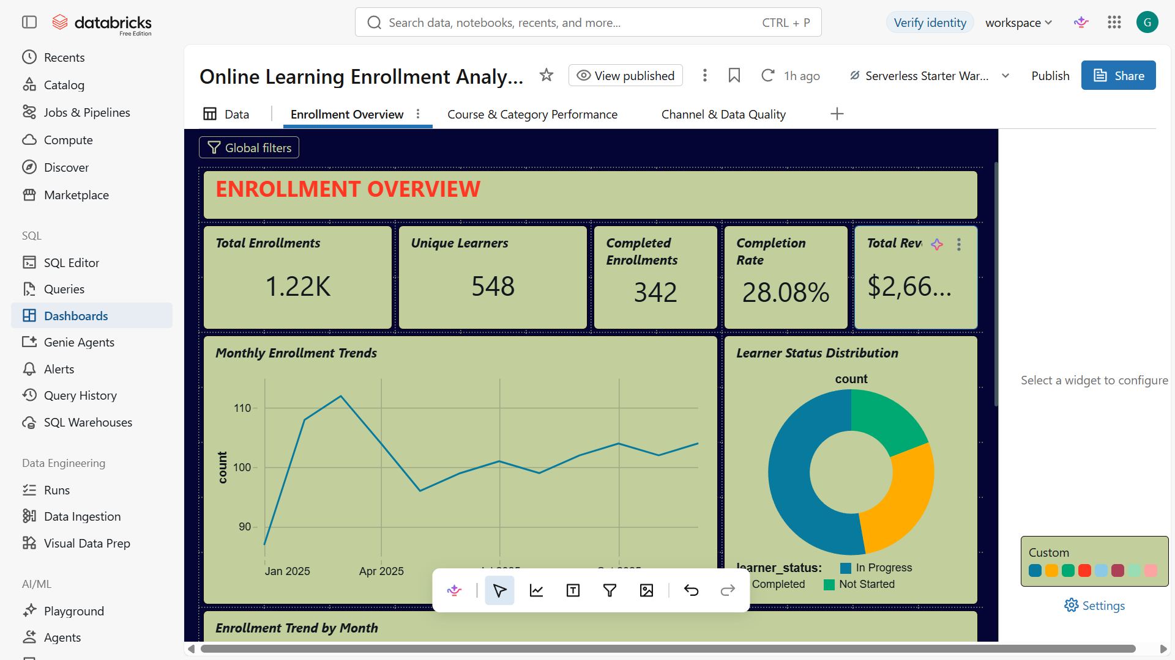

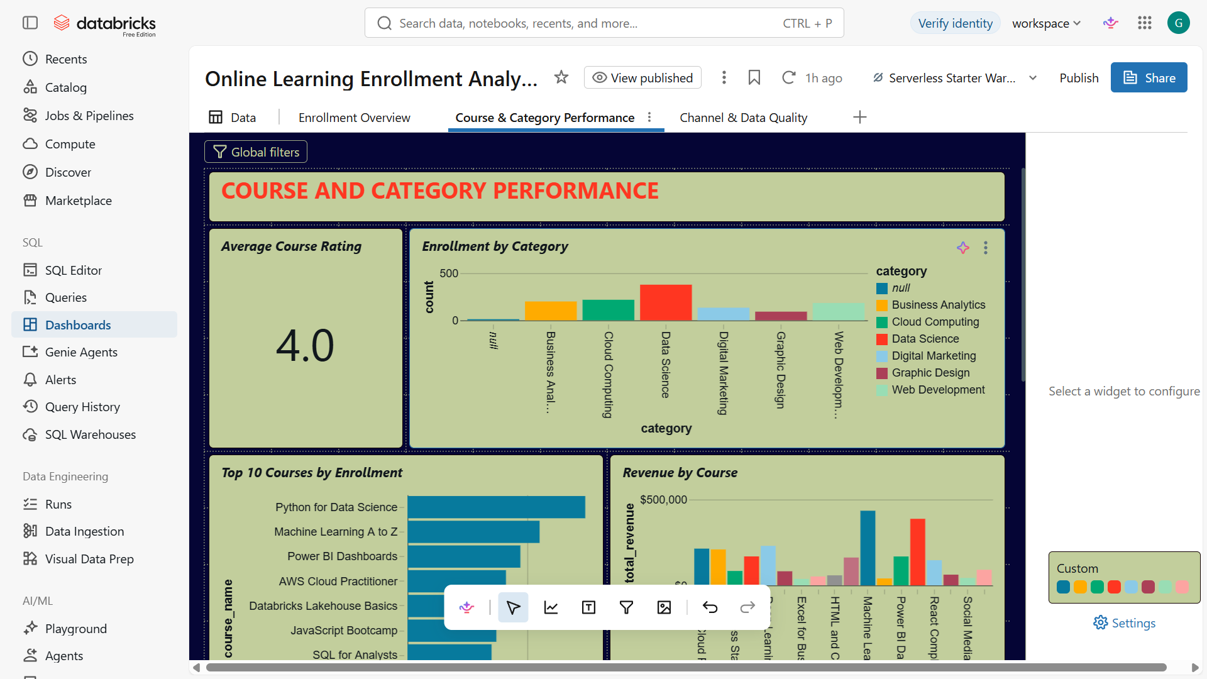

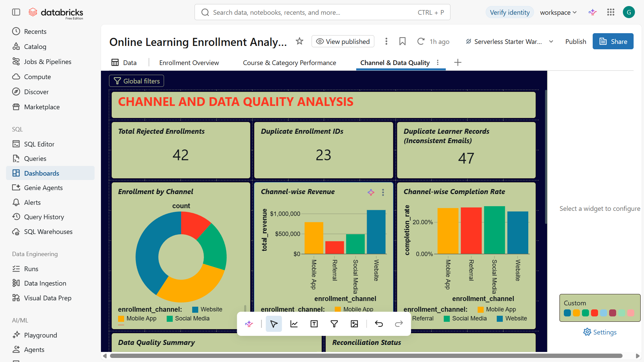
10. Expected Business Outcomes
The completed platform is intended to help an online learning business:
- Monitor monthly enrollment growth.
- Identify popular courses and categories.
- Understand learner completion behavior.
- Analyze revenue generated through courses.
- Compare enrollment channels.
- Identify data quality problems.
- Improve the reliability of business reporting.
11. Conclusion
The Online Learning Enrollment Analytics Platform demonstrates how raw enrollment data can be transformed into reliable business information using Databricks.
By implementing the Medallion Architecture, the project establishes a structured approach to raw data ingestion, data cleaning, validation, and business-level aggregation.
The Gold summary tables provide a foundation for interactive dashboards and business analysis. The planned workflow automation will further improve the repeatability and maintainability of the solution.
Overall, this project demonstrates practical Data Engineering concepts, including data ingestion, Delta Lake storage, SQL transformations, data quality management, layered data architecture, and business analytics.

